Carmichael Arena Accessibility Information
The School of Government parking entrance is our accessibility parking area. You are required to have either an ADA plate, permit, or placard to use this area.
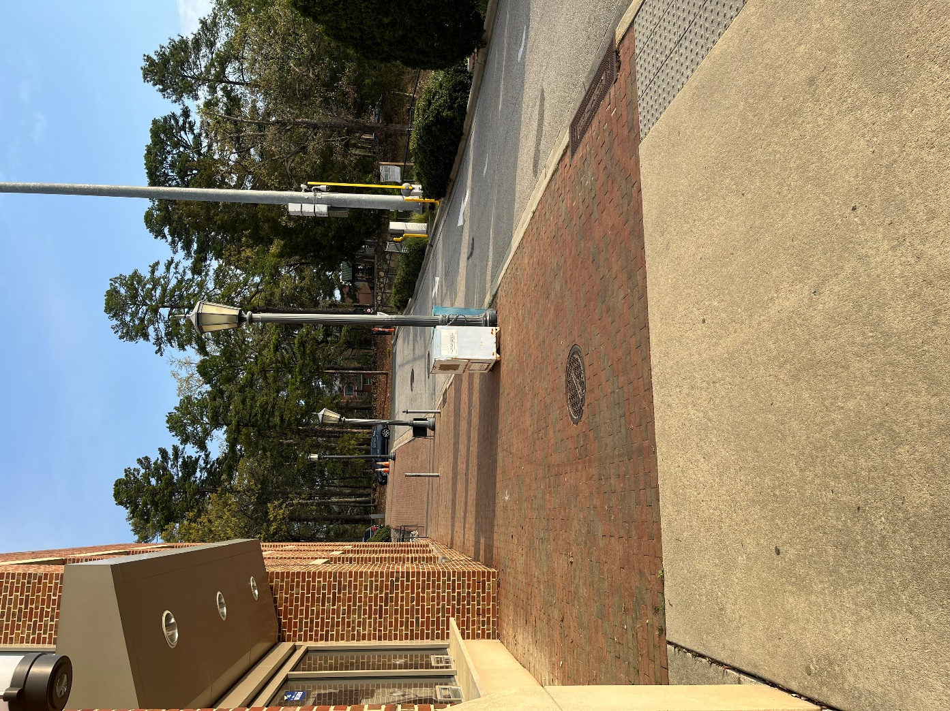
Limited drop-offs may be permitted in front of Carmichael, however there is a steep hill to get down to Carmichael’s entrance that may be an issue for some. And the area will be very busy and crowded.
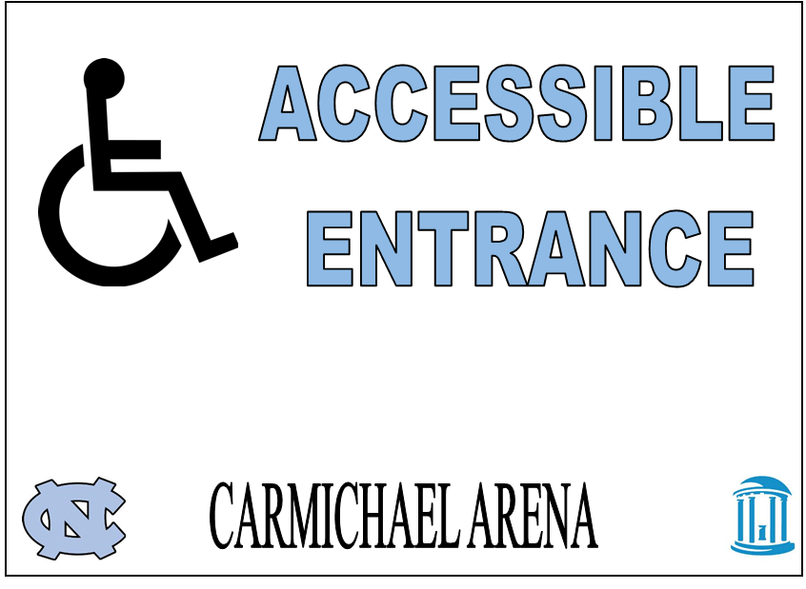
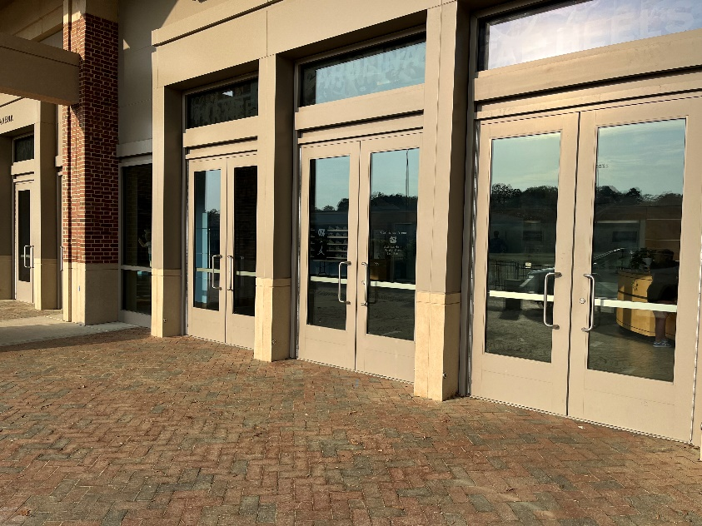
To enter, guests who need extra time can use the far right entrance doors. Signs will label these doors. If you would like to sit in a wheelchair during the ceremony, please bring your own.
Once in the arena, wheelchair/scooter users can pull into any wheelchair/scooter spot along the walkway. Only one companion is permitted to sit with each wheelchair user. No steps are required to get to this area.
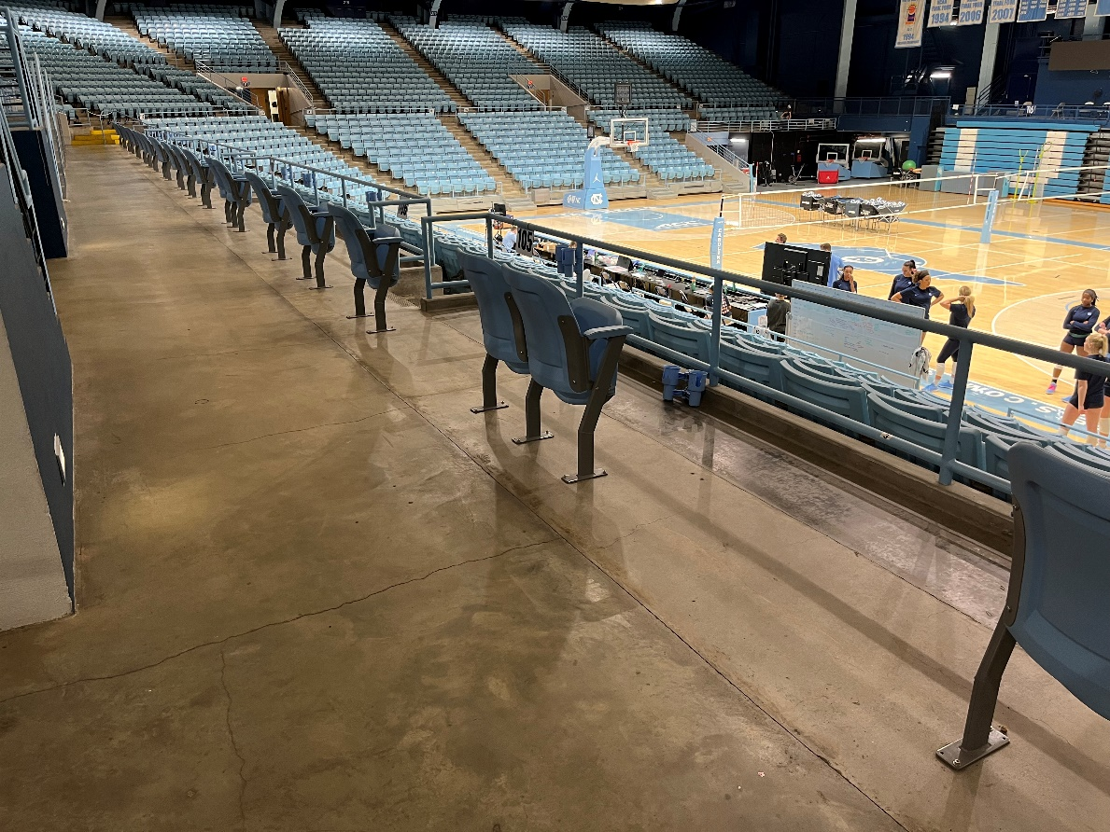

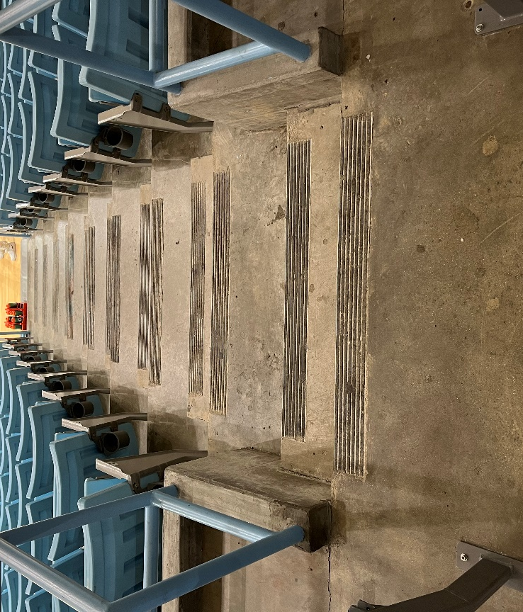
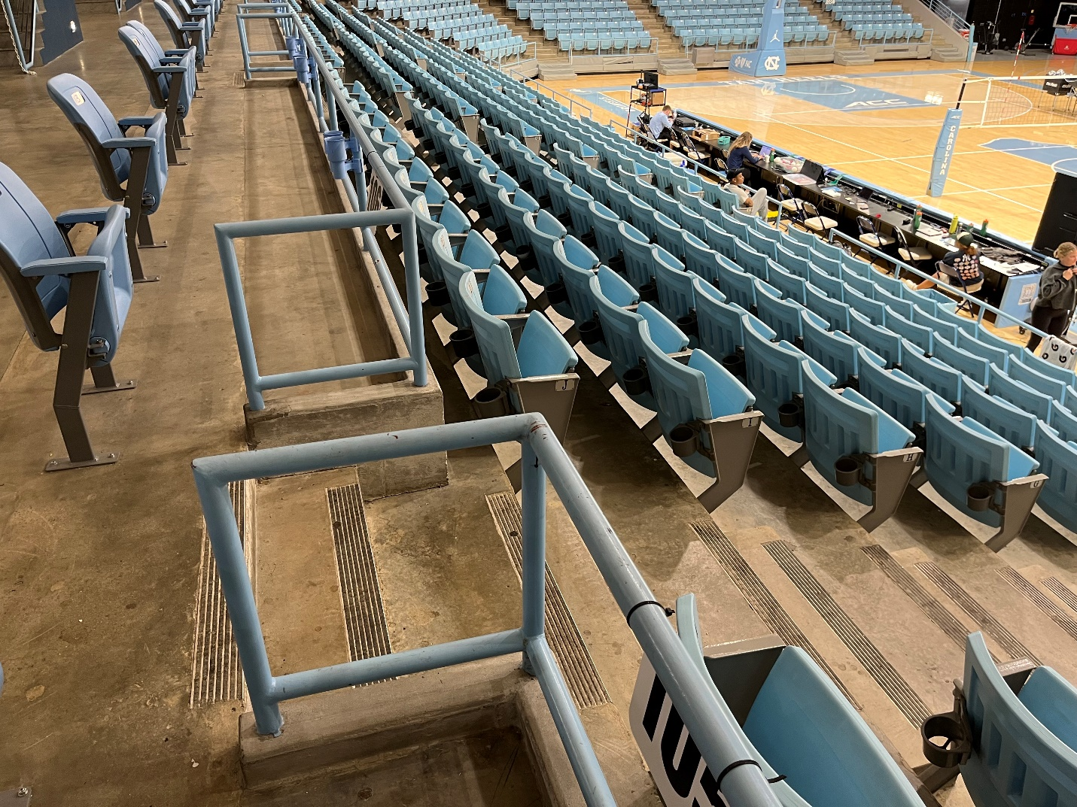
The first few rows in front of the wheelchair row will be made available to accompany other guests who have accessibility issues. Please know that this row does have a few steps in order to access it.

